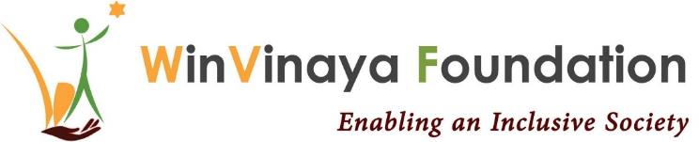__________________________________________________

Disability Sensitization Package Program

Proposal by

WinVinaya Foundation

To

Accenture

Date of Proposal: 22nd Nov 2021

Version 1.0

Project Contact: Sivasankar Jayagopal

Founder Chairman

WinVinaya Foundation

25/3 Brindavan 3rd Cross, Saraswathipuram

IIM Post

Bengaluru 560 076

Ph.: +91-96764-33359

Email: [Shiva.Jayagopal@WinVinayaFoundation.org](mailto:Shiva.Jayagopal@WinVinayaFoundation.org)

Table of Contents

Revision History 3

1 Project Summary 4

2 Introduction about WinVinaya Foundation 4

3 Statement of Scope 4

4 WinVinaya’s Approach 5

5 Guidelines 6

6 Assumptions 6

7 Recommended Milestones 6

8 Commercials 6

9 Thanks for the Opportunity 7

10 Appendix 8

10.1 Disability Awareness Orientation (DAO) 8

10.2 Disability Sensitization Workshop (DSW) for Hiring Managers 8

10.3 Mentoring Support for Hiring Managers, Delivery Teams 9

10.4 Indian Sign Language Orientation (ISLO) 9

10.5 Sign Language Interpretation Support 10

# Revision History

| **Version** | **Effective Date** | **Brief Description of Change** | **Reference for Change** |
| --- | --- | --- | --- |
| 1.0 | 22-Nov-2021 | First Version | N/A |

# Project Summary

Accenture is a multinational professional services company that specialises in IT services and consulting. Inclusion and diversity are fundamental to Accenture’s culture and core values. Accenture is looking for a service provider who can provide Disability Sensitization sessions designed for Accenture Leaders and associates across all entities.

# Introduction about WinVinaya Foundation

WinVinaya Foundation, a Charitable Trust was registered in Feb 2016 by Shiva Jayagopal who is an IT Veteran with 30+ years of industry experience and Seethalakshmi (Akila) who has 17+ years of experience working with Persons with Disabilities. Our primary aim is to empower Persons with Disabilities, economically disadvantaged and women to earn a decent income and lead a life with dignity by providing life skills and resources. We operate a centre in Bangalore and a centre in Tirupur.

WinVinaya believes D&I initiatives has to be holistic and comprehensive. We work with companies to increase their D&I Quotient in addition to training our candidates. This has helped both the companies and the candidates to succeed. WinVinaya conducts Disability Sensitization Orientation, Sensitization Workshops, Sign Language Orientation, Mentoring support through which we sensitize leaders, managers, team members, support teams on the best practices in integrating PWDs in the workplace. This has helped companies succeed not only in recruiting the candidates but also be successful in embracing them and help them grow in their career.

# Statement of Scope

Diversity and Inclusion Journey is like a marathon which takes time to mature and involves culture and mind-set change. Every journey starts with the first step and we will be happy to partner with Accenture in your D&I journey.

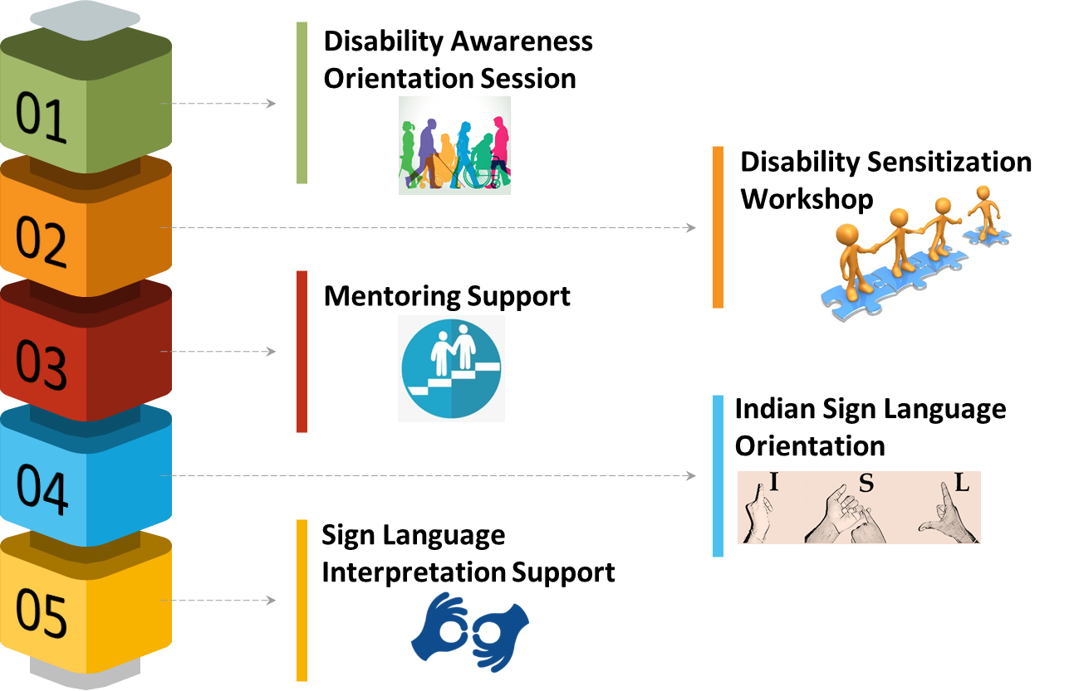

# WinVinaya’s Approach

Our inclusion and sensitization sessions will deliver a social and a cultural storyline to paint a complete picture in favour of creating an inclusive and accessible environment at Accenture.

Our approach is to target Accenture employees in stages as depicted below –

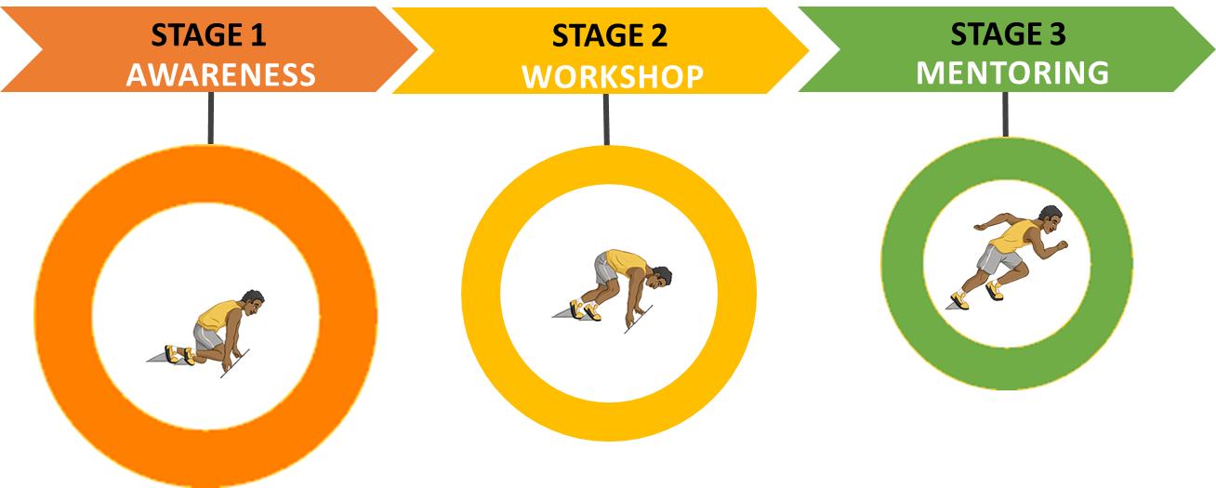

|  |  |  |  |
| --- | --- | --- | --- |
| STAGES | OBJECTIVE | DELIVERY | OUTCOME |
| Disability Awareness Orientation  Duration: 2 hours per session  # Participants: 100 per session | To create awareness and build confidence to work with PWD.  To enable all employees to be more mindful of the needs of the people with disabilities. | The session defines, describes, and details various types of disabilities, disability etiquettes, Intro to Sign Language followed by Q&A session. | To enable change in mind set towards the conducive side of creating an inclusive and accessible workplace environment. |
| Disability Sensitization Workshop  Duration: 2 hours per workshop  # Participants:  15 per session | To emphasize on the joint efforts for stimulating inclusion of people with disabilities at all levels. | The workshop encourages employees to discuss their preconceptions and their fears of interacting with people with disabilities.  They will interact with PWDs from WinVinaya to get a real time exposure. | To remove misconceptions, bring a change in the mind-set of the people and highlight the abilities of people with disabilities. |
| Mentoring PWD & non PWD employees  Duration: For a period of 3 to 6 months | To talk to hiring managers/non PWD team members and PWD team members to provide guidance to issues. | WinVinaya mentor expert interacts with PWD and non PWD employees in a 1:1 session and discusses specific queries and provides necessary guidance. | Integrate PWD candidates into the team, address any issues / potential issues. |

In addition to Disability & Inclusion Orientation, Workshop and Mentoring support, we also provide Indian Sign Language Orientation to make the employees mindful of the disabilities of people and managing to communicate and work with them effectively. Indian Sign language is a beautiful language which is fun, useful and valuable. It can be used anywhere, anytime. Learning sign language could be the best decision one can make in the D&I Journey. We also provide sign language interpretation support when required.

**The detailed objectives and the key takeaways for each of these offerings is explained in** Appendix.

# Guidelines

For all the sessions, there are few guidelines to be adhered to:

* No online session should be recorded
* The number of participants mentioned in each section is the maximum number permitted. The charges remain the same for the sessions with lesser number of participants as well.
* A prior notice should be given for Mentoring Support and Sign Language Interpretation Support.

# Assumptions

For all the sessions, the assumptions made are:

* All sessions are **online** (using Accenture approved online meeting tool)
* Accenture will communicate to employees via sensitization e-mailers on what’s new in this space to look forward to
* Accenture will ensure timely payments to the vendor owing to Accenture Payment terms and conditions

# Recommended Milestones

The high level milestones:

|  |  |  |
| --- | --- | --- |
| ACTIVITY | FREQUENCY | IN A QUARTER |
| Disability Awareness Orientation Session | Once a month | 3 sessions |
| Disability Sensitization Workshop | Twice a month | 6 sessions |
| Mentoring Support | Weekly | 10 to 12 sessions |
| Indian Sign Language Orientation | 2 sessions a week for 5 weeks | 2 batches |
| Sign Language Interpretation Support | On need basis | On need basis |

# Commercials

|  |  |  |
| --- | --- | --- |
| ACTIVITY | # PARTICIPANTS | TOTAL |
| Disability Awareness Orientation Session | 100 per session (max) | ₹ 25,000 per session |
| Disability Sensitivity Workshop | 15 per session (max) | ₹ 25,000 per session |
| Mentoring Support | - | ₹ 1,000 / Session  (Max 1 Hour per Session) |
| Indian Sign Language Orientation | 10-15 per batch (max) | ₹ 25,000 per batch |
| Sign Language Interpretation Support | - | ₹ 1,000 / Session  (Max 1 Hour per Session) |

For the Orientation Session and the Workshop, the invoice will be raised at the end of the session. For Mentoring Support and Sign Language Interpretation Support, the invoice will be raised at the end of every month. For the ISL Orientation, the invoice will be raised at the end of the orientation for each batch.

Payment is to be done within 30 days from the invoice date. Payment is to be made by electronic transfer.

# Thanks for the Opportunity

We thank Accenture for giving us this opportunity to create awareness, sensitize the Accenture employees and orient them in the basics of Indian Sign Language.

We are confident that we will be able to deliver as per the expectations of Accenture – to positively influence and impact the attitudes and behavior of the participants towards the persons with disabilities who they will work along.

# Appendix

## Disability Awareness Orientation (DAO)

**Objective of DAO**

The objective of this awareness session is to build a disability confident organization. The session will cover the following topics with a brief introduction to various disabilities and special focus on hearing impairment and other co-morbidities.

* Defining Disability
* Facts & Statistics
* Types of Disabilities (Visible & Non-visible)
* Inventions meant for PWDs that helped all
* Disability – A Business Case
* Diversity & Inclusion Framework
* Disability Etiquettes
* Some do’s and don'ts when interacting with people with disability
* Introduction to Indian Sign Language
* Tips for interacting with persons with disabilities
* Success Stories of PWDs in Corporates

**Key Takeaways of DAO**

The session will make Accenture a disability confident workplace, while making Accenture a more enlightened place to work, and helping to change attitudes and behaviours for the better on a macro level. It aids in making Accenture a collaborative and non-discriminatory organization.

## Disability Sensitization Workshop (DSW) for Hiring Managers

**Objective of DSW**

The objective of the workshop is to alter mind-sets, address fears, confusion, break stereotypes, and bust myths about people with disability. What the workshop will cover:

* Recap of Disability Sensitization Awareness Session (Defining Disability, Facts, Myths & Misconceptions)
* Best Practices followed by Inclusive Companies in Recruiting PWDs
* Introduction to Deaf Culture
* Introduction to Indian Sign Language (alphabets, key phrases)
* Tips for interviewing persons with disabilities – across disabilities
* Introduction to Workplace Solutions/ Reasonable Accommodation
* Interaction with Employees of WinVinaya who are Persons with Disabilities
* RPwD Act - Overview of the disability law
* Some Ideas on “What Can You Do?”

**The participants of this workshop should have attended the Disability Awareness Orientation session.**

**Key Takeaways of DSW**

This workshop closes the gap between those employees without disabilities and those with disabilities, it is about removing barriers and embedding best practice so that everyone feels comfortable and empowered to be themselves within the workplace, to flourish and to achieve their full potential. It leads a way toward promoting a harmonious and productive workplace environment.

## Mentoring Support for Hiring Managers, Delivery Teams

While trainings are very useful to increase the awareness and D&I maturity levels of employees, it is NOT adequate for a successful integration of Persons with Disabilities into the organization. Once the candidates join the team, Accenture employees might have questions that need clarification/ guidance. Even the new candidates might have doubts/ questions that they might be uncomfortable asking the Accenture Team.

WinVinaya suggests a 3 to 6 month mentoring support for the hiring managers and delivery teams, after the candidates are hired. During these online sessions, WinVinaya meets with Hiring Managers, Delivery Teams and PWD employees to check how well the integration of the latter into the team is happening, any issues/ potential issues that need to be addressed, provide ideas/ guidance where required.

## Indian Sign Language Orientation (ISLO)

There are 100+ sign languages available across the globe. Like spoken language, Sign Language also takes time and practice to learn and get better. WinVinaya conducts orientation in basics of Indian Sign Language to help create a better culture of inclusivity. Learning sign language can be a fun experience and help the Accenture employees to communicate with people in the deaf and hard of hearing community. It will bridge the gap between hearing and deaf employees in Accenture.

The key differentiators of our orientation classes are that the curriculum is tailor made to include visual gestural communication, practice assignments, comprehension with increasing complexity, live conversation practice with deaf person, lessons on deaf culture apart from the regular course curriculum.

**The duration of this orientation for each batch is 10 hours**. Since learning a language involves practice, we have designed the orientation session that such that each session is one hour long and there will be two sessions in a week and 5 weeks to complete the course.

**Objective of ISLO**

The objective of the orientation is to learn the basics of sign language which include the alphabets, everyday phrases and ways to communicate with deaf persons. The topics covered:

* Deaf Culture
* Basics of sign language
* Topic based words in sign language
* Ways to train or teach deaf
* How to communicate using basic/natural sign language
* Role of interpreters and how to work with them

**The participants of this workshop should have attended the Disability Awareness Orientation session.**

**Key Takeaways of ISLO**

Few of the key takeaways from this orientation are:

* Introduces the participants to the deaf culture and community - get to know the rich history of deaf culture and deaf community.
* Enables participants to become more diverse – With the knowledge of sign language, participant’s connection will extend to the deaf community, and it prepares her/him to handle the communication barriers. The sign language can help make the workplace more diverse.
* Allows participants to make new friends – She/he can build relationships and get to know each other, online and offline.
* Be able to help when required - Participants can overcome any communication barriers with her/his deaf peers by speaking in sign language.

## Sign Language Interpretation Support

Effective communication is vital in a team. To be effective, communication needs to be inclusive and engage everyone. While Accenture is taking steps to make the workplace environment more inclusive by training the employees to interact with their deaf counterparts, engaging a professional interpreter offers an excellent way for deaf and hard of hearing employees to get more from 1:1 interactions, meetings and training sessions that are very important, by allowing them to feel fully informed and able to contribute their input.

WinVinaya offers this support – whenever a crucial meeting or a training is planned by Accenture for the participants including deaf employees, Accenture can reach out to WinVinaya for sign language interpretation. The pre-requisites for this service are:

* Sign language interpreters are available on weekdays (Monday to Friday) from 9 AM to 5 PM.
* A prior notice is to be provided to WinVinaya before at least 3 days before the session to arrange for the interpreter.
* For a meeting or a training, the maximum number of deaf participants should be 15.